CSCI 5010 – Fundamentals of Data Communications

Lab 3

IP Addressing

University of Colorado Boulder

Department of Computer Science

Network Engineering

Professor Levi Perigo, Ph.D.

# Summary

This lab is intended to be an overview of IP addressing, the two formats in which IP addresses can be represented (IPv4 and IPv6) and the difference between public and private IP addresses. This lab will be a baseline for future exploration into these topics used throughout this course.

The questions in the lab are intentionally vague. The purpose of this is for you not only to research, investigate, and learn the technologies, but also become proficient at interpreting both non-technical and technical questions. Being able to research and discover answers on your own will be critical as you progress in your career.

# Note: Feel free to use your laptop or VMs provided for any objective.

# Objective 1: Public and Private IP addresses

1. Using the command prompt, find your laptop’s IP address.
   1. Submit the IP address here (also note how the address was obtained (static/dynamic/etc.) [**1 point**]

192.168.1.35 – dynamic.

1. Navigate to the URL: [www.ipchicken.com](http://www.ipchicken.com). What IP address does it indicate? Is it different from the address above? Why or why not? [**2 points**]

75.70.235.45. It is different than the address above because that IP is my public IPv4 address

1. Execute a traceroute on your laptop to any URL. Provide a screenshot of the output [**1 point**].

* 1. Do all the IP addresses in the trace belong to the same network? What do these IP addresses represent? Is there any additional information you can obtain about these replies that you can gather? [**15 points**]

They all do not belong to the same network. I think the IP addresses represent routers that are routing my traceroute to google.com. For example the third traceroute had three Ips that I think are in the same network. I think they hopped between each other to find which router could route the ‘ping’ to the next network or router. Some routers have domain names which identify what ISP there from and from what general area. As you can see in the 4th hop, those group of routers are from a server area in Denver which is owned by Comcast.

* 1. Which of these are private IP addresses and which of these are public? How did you differentiate, and why would some be public and some private? [**10 points**]

To my best knowledge, the first two hops are private because they are in my network and the rest are public. I could differentiate whether Ips are private or public if those addresses fall into the private IP address class range. The first 2 hops had IP addresses in class A and C while the rest of the Ips were public.

1. What are the IPv6 address that your system obtained? [ **1 point**]

inet6 fe80::1052:60b:1923:839e%en0 prefixlen 64 secured scopeid 0x6

inet6 fd11:10ed:e67f:7d9d:8be:a22b:5bc8:fcf7 prefixlen 64 autoconf secured

1. Repeat **Obj1.2** using any tool of your choice? What IPv6 address do you see on the public domain? Is it same as the seen above? Why or Why not?? [**10 points**]

It is the same seen above because I do not have a private IPv6 subnet set up on my machine. It was given to me by the ISP.

# Objective 2: IP Address Format

Note: Prefer using your own laptop instead of the VM, since assigning a static IP to VM might result in losing connection.

1. While connected to the CU campus network, run the command to find your laptop’s IP address from the command prompt again.
   1. How many IP addresses do you come across? Do you see both IPv4 and IPv6 addresses?

I came across 3 Ips. I do see both IPv4 and IPv6.

* 1. Indicate in screenshot [**5 points**]

1. Can you configure an IP address of your choice instead allowing the host to receive an IP address dynamically? If so, include a summary of how you can statically assign an IPv4 address, and provide the screenshot indicating that you have statically configured the IP address [**10 points**]

To assign a static IPv4 address on PC, first go to settings > Network and Internet > Ethernet > Edit IPv4. There you can input IP, subnet, DG, and DNS servers.

1. Explain the formatting of IPv4 and IPv6 addresses. [**2 points**]

IPv4 is 32 bits long consisting of 4 octets. These binary numbers can be converted to decimal to represent an IP. IPv6 addresses are 128 bits long and are in hexadecimal. Each block is separated into 16 bit blocks.

References:

Windows: [How to Assign a Static IP Address in Windows 10 or Windows 11 (howtogeek.com)](https://www.howtogeek.com/19249/how-to-assign-a-static-ip-address-in-windows/#:~:text=To%20set%20a%20static%20IP%20address%20in%20Windows%2010%20or,IP%20details%2C%20and%20click%20Save.)

Mac: [Use DHCP or a manual IP address on Mac - Apple Support](https://support.apple.com/guide/mac-help/use-dhcp-or-a-manual-ip-address-on-mac-mchlp2718/mac)

Note: At any time if you are having issues, revert to DHCP.

# Objective 3:

Using what you have learned from the in class lectures, and from Objective 1 and Objective 2 of this lab, describe the difference between private and public addresses and the need for ipv6 addressing. [**10 points**]

The difference between public and private IP addresses is that public IP addresses are unique, but private addresses can be reused on different networks. Because the internet has gotten so big, the IPv4 space is running out of public IP addresses and because of that, IPv6 was created. IPv6 is 128 bits as opposed to 32 bit and can account for every device connected to the internet and a lot more.

# Objective 4: IPv4 subnetting

1. What is the difference between classful and classless IPv4 addressing? Why do we need classless addressing and subnetting? [**5 points]**

The difference between classful and classless IPv4 addressing is that classful divides the network space into separate class groups like A, B, and C that have a certain limit of networks that can be used by hosts. Classless addressing allows for users to go outside of this class based scenario and create a custom subnet mask that is a different size than these class based criteria.

1. Use the CPT file uploaded on canvas and configure the topology using the subnet 192.168.100.0/24 efficiently. Write down the Interface IPs and subnet details in the space provided on the CPT. [**25 points**]

1. List 2 points to be noted for efficient subnetting? [ **3 points**]
2. When choosing a subnet for a network, consider how many users will be on that network and make a mask that is closest to the number of users on that network. This will make sure you aren’t wasting IP space.
3. When subnetting multiple networks, make each network proceed the last and don’t just allocate networks randomly on the allotted space. It should be a nice line of networks that connect one after the other.

Report Questions:

1. The network graph is shown in Figure. 2.
2. Host H1 sends a packet to the destination 128.96.34.126. Explain how this packet traverses in the network described below. You need to describe who received the packet and what are their reactions. Also trace the return path that is taken. [**2 point**]

This IP is in the same network as H1, as the subnet is a /25 and is not out of scope of the network. So when the packet is sent, it is sent locally in the network via MAC address and is then sent back the same way.

1. Host H3 sends a packet to the destination H1 (128.96.34.15). Explain how this packet traverses in the network. [**3 point**]

The packet from H3 will determine if that IP is in the network, and it is not so it will send that packet to the default gateway or the router. The router will send this packet to the next network and will check if this IP is in the network as well. If it is not, it will send it to the next router and that router will check its network to see if it is in its network. Now the packet is in the same network and will send it to the recipient.

1. The subnet of H1 has now two different teams and would like to split it into two subnets. Please add one more subnet and add R3 and change the network configurations as you need. Note that you are allowed to modify the network as least disruptive as possible. [**3 point**]

H1 will be on its own network with its own router and the new team will be added visually at the bottom with R3 connecting to H3s network. The new subnet of the H1 team will now be: 255.255.255.64 with subnet number 128.96.34.0. The H3 team’s subnet will be: 255.255.255.64 with subnet number 128.96.34.64. Note H1s IP and DG will not change.

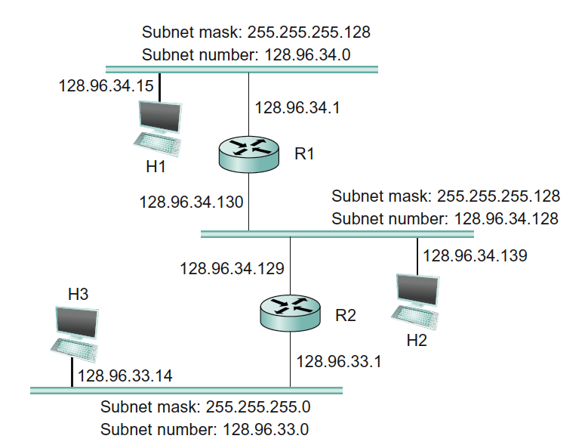

Figure 2.

1. Problem 2

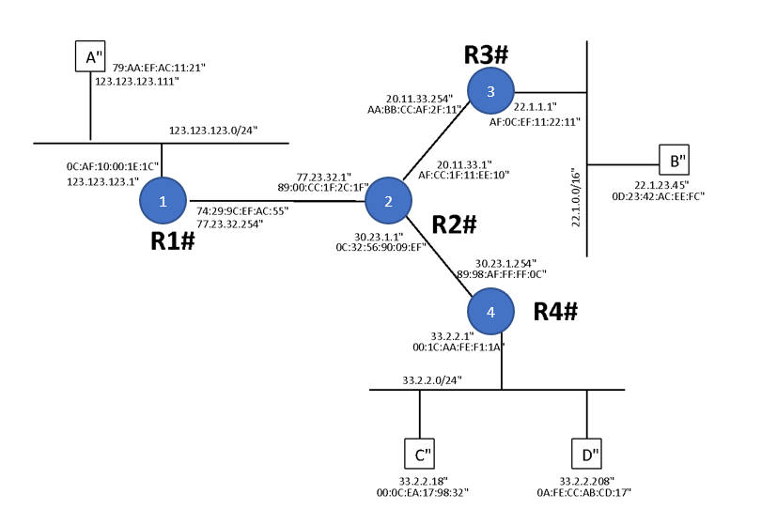

Figure. 3

Above in Figure 3 is the network graph with 4 routers (R1, R2, R3, R4) and 4 hosts (A, B, C, D). Each router interfaces and hosts are labeled with both IP and MAC address, Routing is enabled so that any two hosts can communicate with each other and also the default gateway of each host is set to its gateway router.

1. Suppose that A send an IP packet to B through R1, R2, R3. Write down the IP packet’s content (src MAC, dst MAC, src IP, dst IP) along the path in the Table given below: [**10 points**]

|  |  |  |  |  |
| --- | --- | --- | --- | --- |
|  | src MAC | dst MAC | src IP | dst IP |
| A -> R1 | Mac A | Mac R1 | IP A | IP B |
| R1 -> R2 | Mac R1 | Mac R2 | IP A | IP B |
| R2 -> R3 | Mac R2 | Mac R3 | IP A | IP B |
| R3 -> B | Mac R3 | Mac B | IP A | IP B |

Table. 1

1. When C sends out an ARP query for its default gateway, what is the reply to that query? [**2 points**]

The reply to that query is the MAC address of the default gateway.

# Total Score = ________________/__120__